**Final Project: Toiletries Case**

# **Operations & Maintenance: User's Manual**

**ENGR 1202 M03**

**05/05/2023**

**Document:** Quality Enhancement Paper- Project Team 8

# Table of Contents:

Chapter 1: System Overview 3

1a. Part List 3

1b. Box Body System Overview 4

1c. Box Lid System Overview 5

1d. Box Pin System Overview 6

Chapter 2: O&M Roles and Responsibilities 6

2a. Assembly Procedure 7

2b. Operation Procedures 7

2c. Maintenance Procedures 8

2d. Warranty Procedures 9

Chapter 3: Contact Us 9

# System Overview

Ever Clean™ is a toiletry box designed to fit your necessary needs while protecting your accessories from a surface that may have a questionable level of "clean". The box is sturdy enough as a strong, sealed box, to protect any luggage it might hold.

The toiletry holding box was created with multiple aspects in mind, including airport safety standards*, luggage protection, and countertop space. The design is made from injection molded plastic components, ensuring this product is flexible and tough enough to handle reasonable travel in any suitcase, carry-on, or pocket.

Ever Clean™ uses new patented technology to divide its space into sections, permitting users to stand their accessories in such a way that there is limited contamination and no contact with dirty countertops. The lid also functions as a pseudo-counter, with enough space to act as a temporary stand for various items. Ever Clean™ includes enough space for multiple people to store their toiletries.

The most important function for any toiletry box is portability. With luggage size constraints shrinking, Ever Clean™ offers a great solution for compact baggage needs. No more vacations giving up space in your luggage with your present holder; Use Ever Clean™!

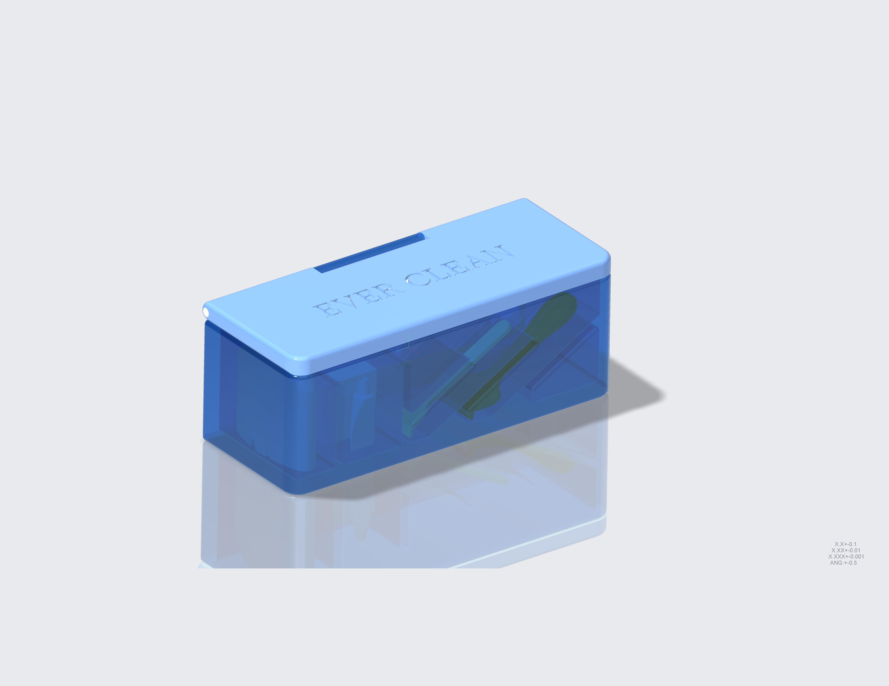

*Figure 01

*Airports require that passengers have their liquids (gels, lotions, shampoos, toothpastes, etc.) visible for inspection in a separate transparent bag. Liquid items are not included in Ever Clean.

## 1a. Part List

Ever Clean ™ is composed of three parts: the body, lid and pin. Requires assembly.

*Figure 02

|  |  |  |  |
| --- | --- | --- | --- |
| Part List |  |  |  |
| **QTY.** | **PART #** | **DESCRIPTION** | **MATERIAL** |
| 1 | 1A-00 | Box Body | injection molded plastic components |
| 1 | 2A-00 | Lid | injection molded plastic components |
| 1 | 3A-00 | Pin | injection molded plastic components |

## 1b. Box Body-System Overview

The main function of the box’s body is to hold toiletries or utensils. It does not include the lid or pin. The body has unique grooves and dividers that function as a stand. This prevents users’ toiletries from getting mixed together, contaminating, or contacting a countertop.

Ever Clean™ includes separate spaces for toothbrushes, body deodorant, floss, contact lens cases, combs, razors, and more. It includes enough space to fit multiples of the same object, so more than one person can use Ever Clean™.

The box’s design includes spaces for various user-selected objects and spaces designated for specific objects. Ever Clean™ features a body with unique ribbing structures, creating a range of sized spaces to store toiletries. There are even spaces primarily designed for razors and toothbrushes.

The box’s body minimizes the overall size of the box while functioning as a holder for all toiletry holding needs.

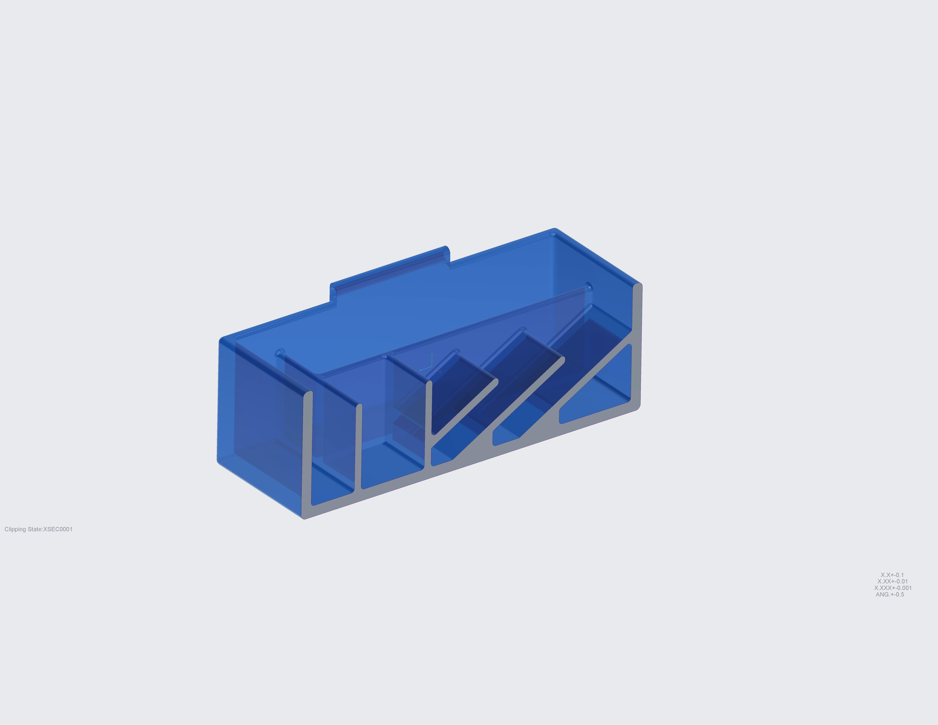

*Figure 04

*Sectional view of body component

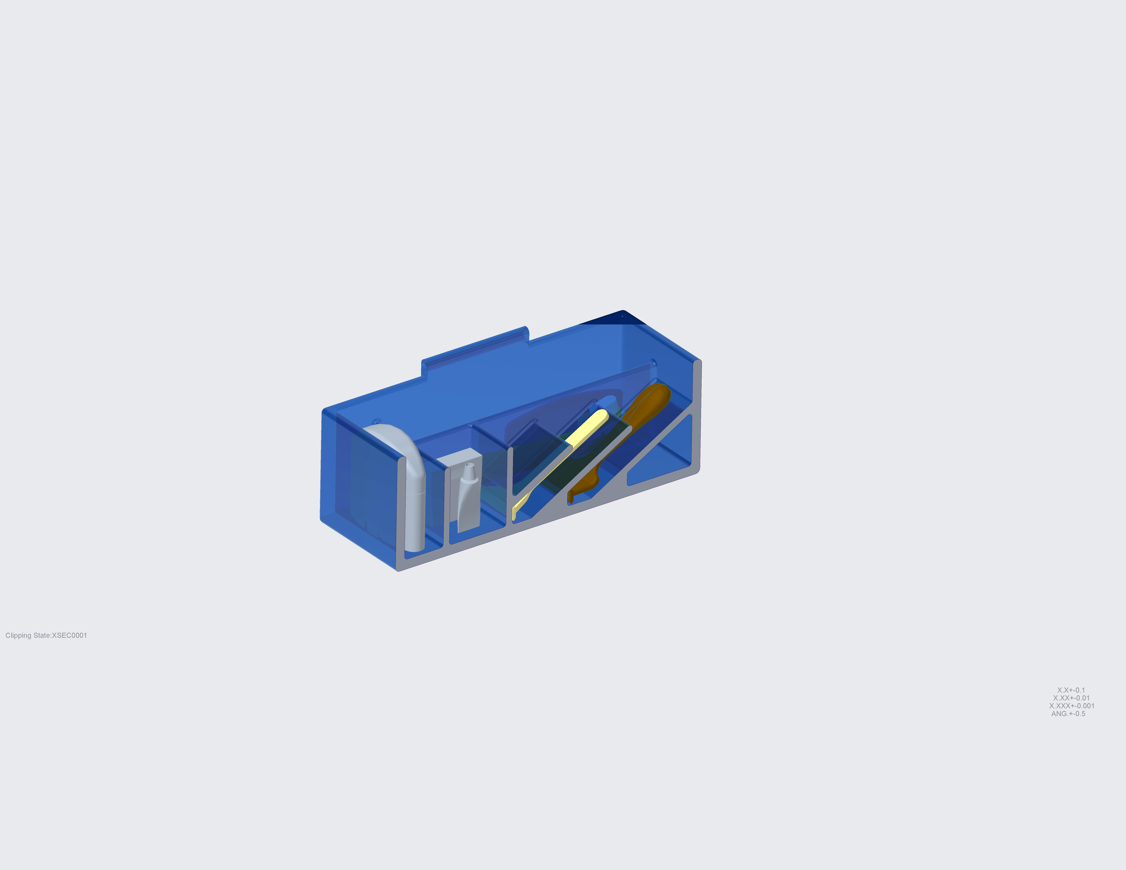

*Figure 05

* Recommended for use of 1-3 people

* Ever Clean™ can hold up to three toothbrushes and two razors

1c. Box Lid-System Overview

The lid component of Ever Clean™ is a part of the container that features a flat surface serving to close the box. When coupled with the pin, it acts as a hinged, sealing mechanism to the overall box system. It also functions as a mini countertop (when the box is assembled) that can temporarily hold toiletries.

The lid can be lifted, shut, and removed.

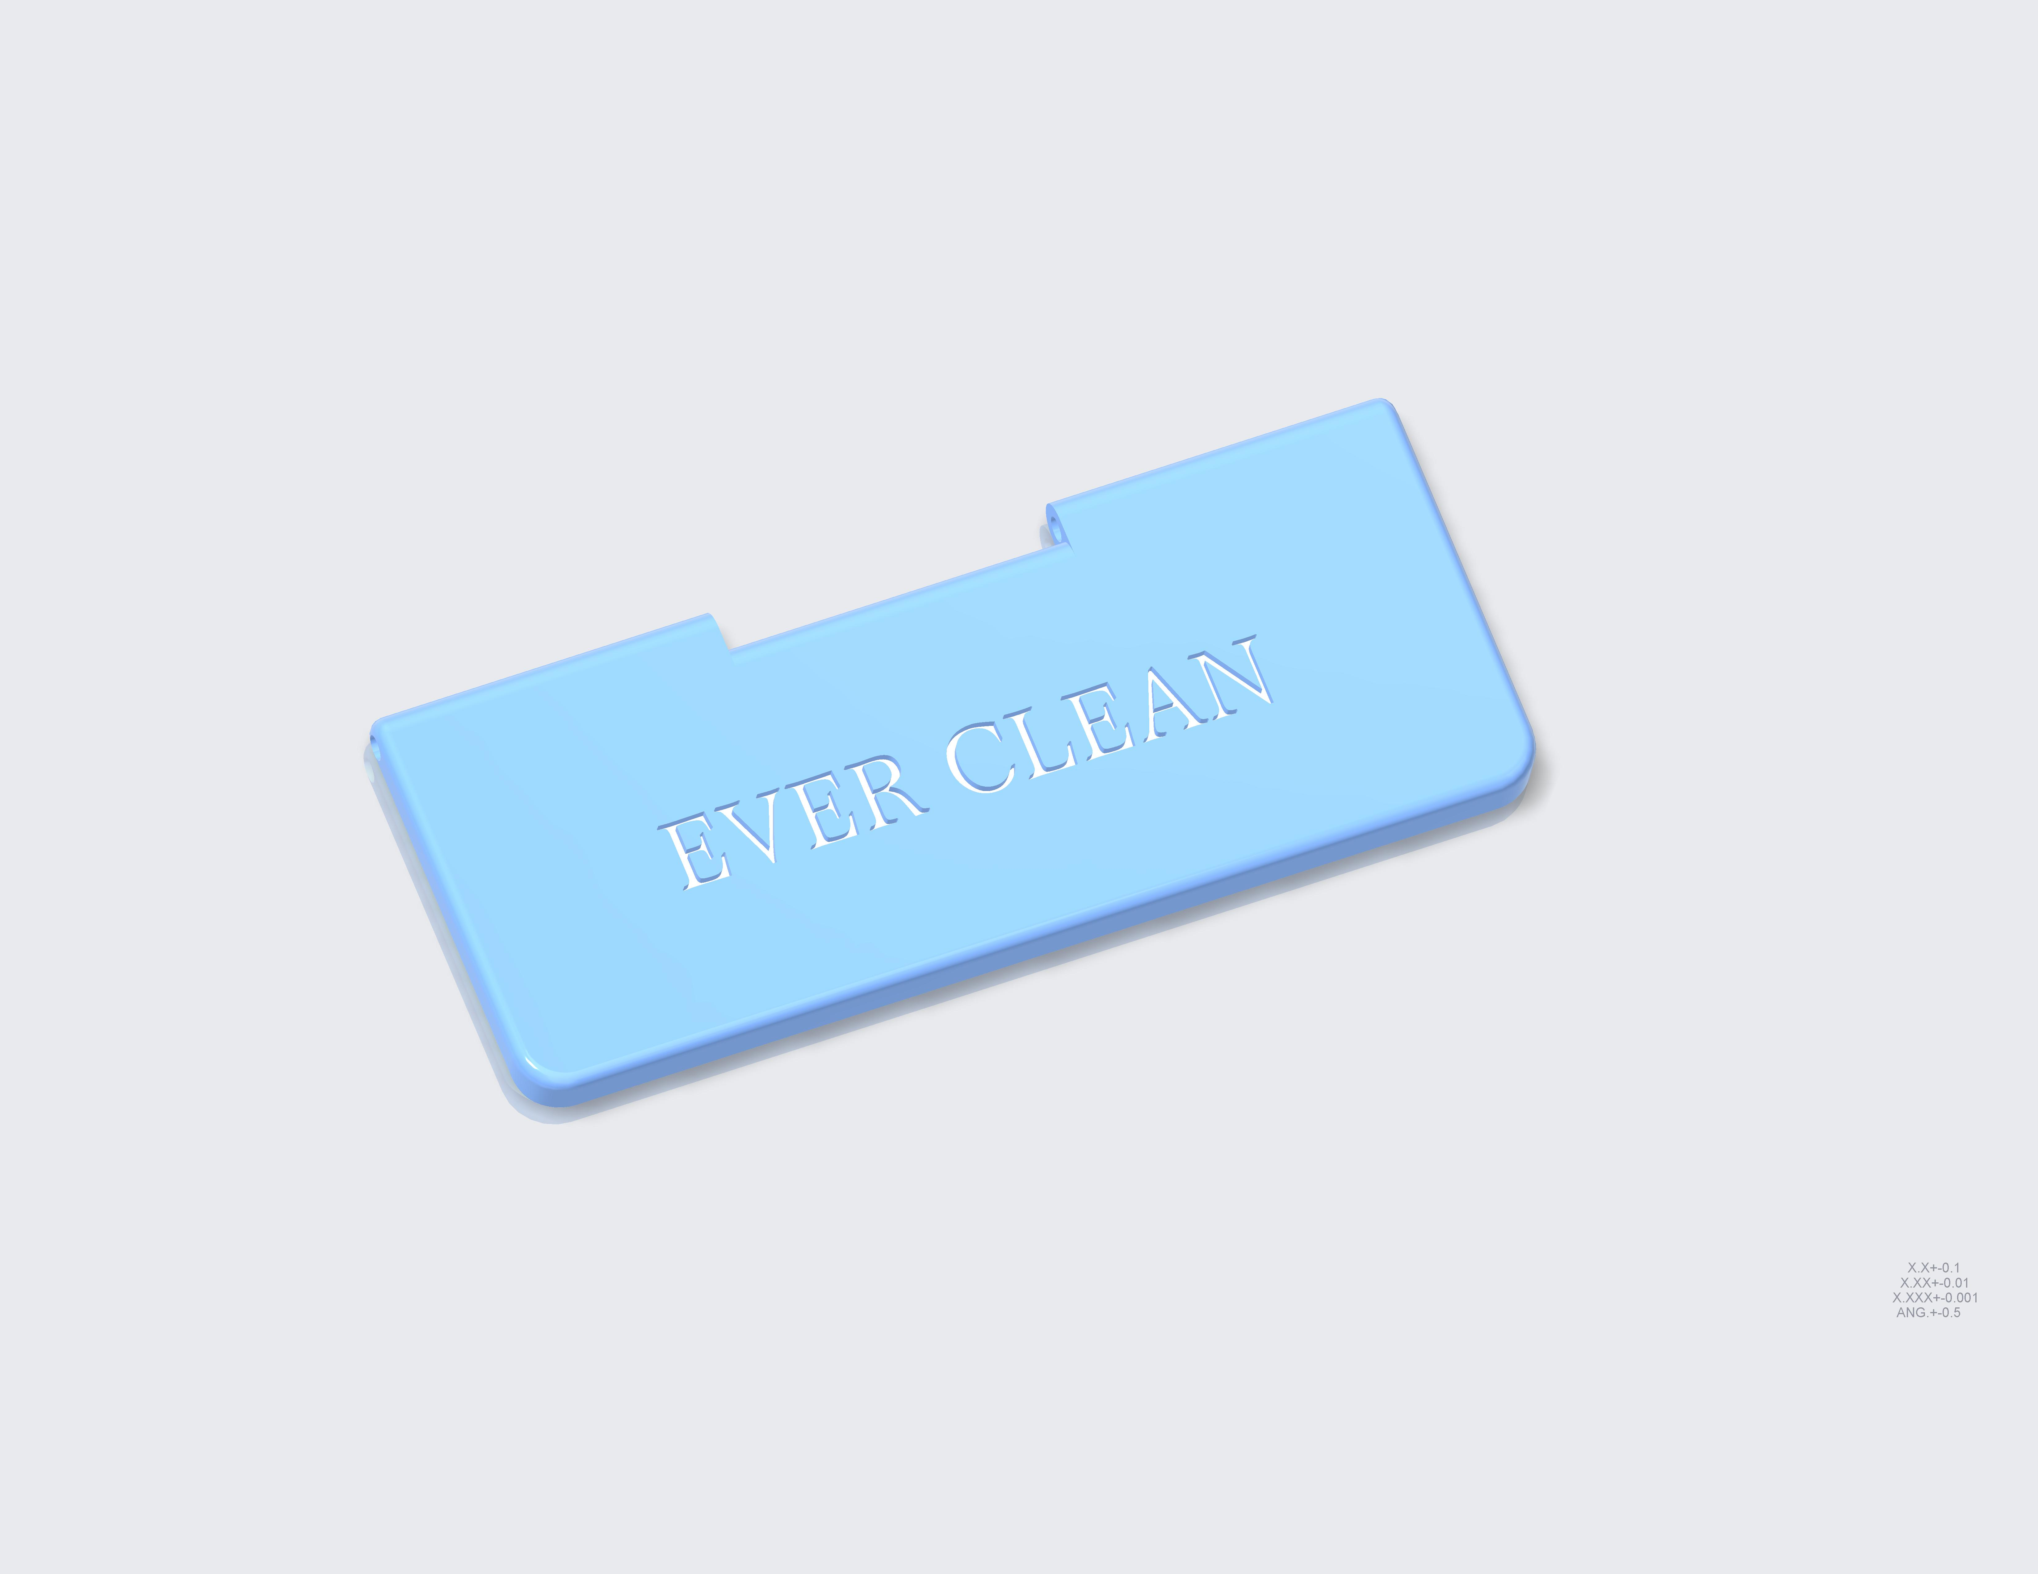

*Figure 06

## 1d. Box Pin-System Overview

The pin component of Ever Clean™ is a press fit dowel pin. It fits tightly into the lid and box parts, not moving after installation. The dowel pin is a peg of plastic holding together the components of the Ever Clean™.



Figure 07

*Tool to install pin is not included

# O&M Roles and Responsibilities

2a. Assembly Procedure

Ever Clean™ can be manually assembled in four main steps. Additional tools for assembly may be required.

Step One: Locate the box body (1A) and lid (2A) parts. Hold the lid so that its non-flat edge is facing the box body’s protruding edge (See figure 08).

Step Two: With the worded side facing away from the box body, slowly push down until the parts (1A & 2A) are flush against each other. There should be no room for the lid to be further pushed down.

Step Three: Push the worded side of the lid downwards until it is flat against the box, making the box appear closed (See figure 08). Locate the pin part (3A) and hold the pin so that it is facing the holes in the lid (2A) and the box body’s (1A) protruding edge.

Step Four: Slowly insert pin into the holes until the pin no longer sticks outward. The pin should not extend past the edges of the lid and box body (See figure 08).

*Figure 08

*Product does not include toiletries

## 2b. Operation Procedures

The Ever Clean™ is made to be used as a portable container that holds body hygiene and toiletry supplies such as toothbrushes, toothpaste, dental floss, and other personal items.

To use after assembly, open the lid, which operates under a self-opening function, and place toiletries inside. Toothbrushes and razors have a select area they fit into. These areas are visible upon opening.

When done placing objects, simply push the top of the lid down to close the Ever Clean™. The lid will stay closed until opened during the next use of the box. When closed, the box will keep out contaminants or moisture from its surroundings.

*See figures 05 and 09 for the recommended placement of toiletries within the box.



Figure 05 Sectional Front View

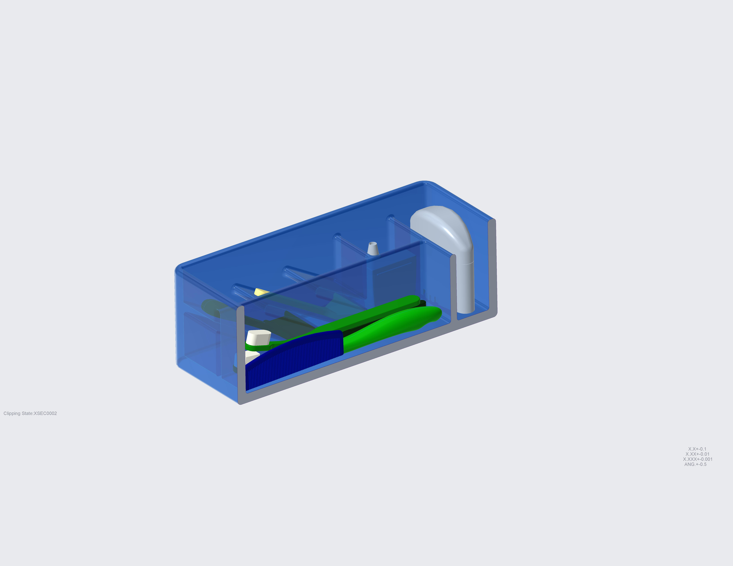

Figure 09 Sectional Rear View

## 2c. Maintenance Procedures

Ever Clean™ is recommended to be cleaned after each use. To clean, open the lid and wash the inside with soap and water. Leave out to dry before closing the lid again. Prolonged exposure to moisture can result in molding or a presence of mildew within the container.

If Ever Clean™ becomes stained, use an all-purpose cleaner with a soft bristled brush or other non-abrasive cleaning utensil to remove the stain. Using an abrasive cleaner or cleaning tool can scratch or damage the Ever Clean™.

If a stain remains, make a solution of water and bleach, using one tablespoon of chlorine bleach per cup of water, and lightly scrub the surface.

The box contains many sections of various sizes that can trap moisture, dirt, or other contaminants. Make sure to clean all spaces in the Ever Clean™. See figure 10 for more details.

*Figure 10

## 2d. Warranty Procedures

Thank you for your interest in Ever Clean™. This warranty applies to physical goods purchased from Project Team 8.

This limited warranty covers any defects in material under normal use while under the warranty period. During the warranty period of sixty days after purchase, Project Team 8 will replace, at no charge, any parts that have proved defective due to improper material, under normal use and maintenance.

**This limited warranty does not cover malfunctions or damage that has not resulted from improper materials or craftmanship.**

To obtain a warranty service, contact the service center for further information.

# Contact Us

The Service Center is located at 9330 Robert D. Snyder Rd, Charlotte, NC 28223.

Phone Number: (910)617-6699

Email(s):

aleland@uncc.edu

ssanch23@uncc.edu

jbrow482@uncc.edu

avreela1@uncc.edu